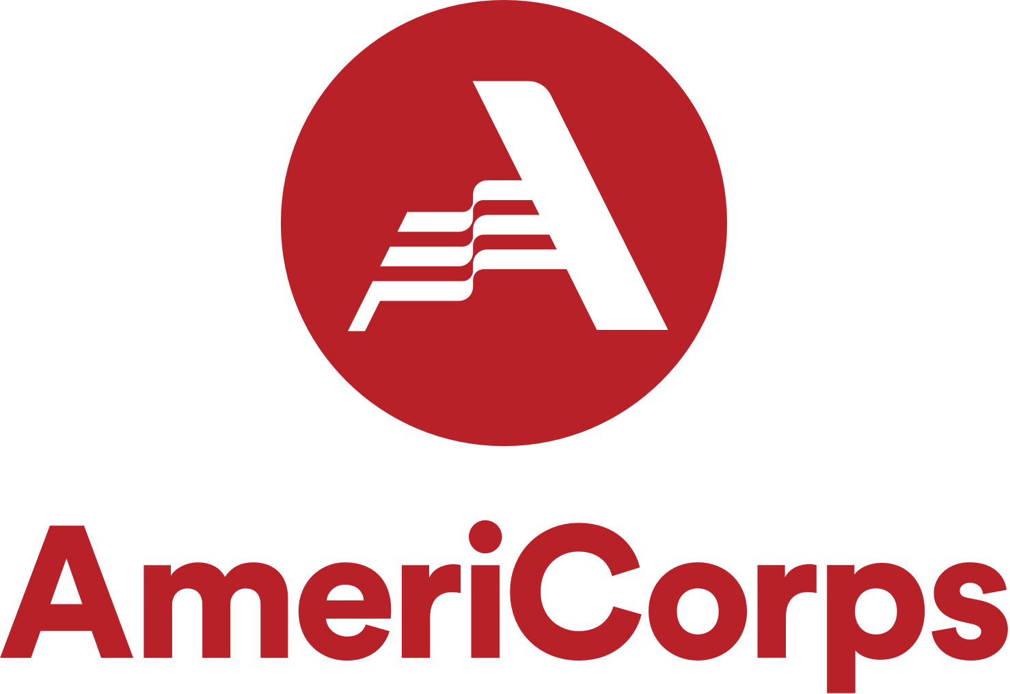
Position Description
Volunteer Maryland AmeriCorps Member
at Community Ecology Institute

PURPOSE AND SCOPE:

This is an 11 month, full-time (40 hours/week) AmeriCorps member position with Volunteer Maryland (VM) at the Community Ecology Institute. Volunteer Maryland AmeriCorps members, ACMs, are responsible for building capacity and developing and implementing a volunteer program. The member will focus on increasing the Service Site’s effectiveness, efficiencies and/or expand the Service Site’s reach or scale. The outcome will be an increase in capacity for the Service Site to serve their identified community. The VM service year will begin in September of 2022 and conclude in August of 2023; members must complete 1,700 service hours during the term.

SITE SPECIFIC PROJECT SCOPE:

The Volunteer Maryland AmeriCorps Member will aim to engage and support hundreds of people who volunteer at our Freetown Farm location in Columbia. Volunteers include individuals, families, Scouts, community groups, businesses, etc., many of which volunteer on a regular basis. This role is approximately 2/3 on-site at the farm coordinating and overseeing volunteers, and 1/3 computer based coordination, including team meetings and email communication. This job requires extensive time participating in physical outdoor work.

BENEFITS:
VM AmeriCorps members receive a living stipend of $16,502 (pending funding from the Governor’s Office on Service and Volunteerism), and health insurance if they are not already covered. They may also qualify for a childcare allowance. Other benefits include mileage reimbursement for site-related travel, student loan deferment, professional training, valuable networking opportunities, working with a dedicated team of AmeriCorps members and staff, and making a real difference in a local community. After completion of a successful service year, members receive an education award of $6,495 through the Segal AmeriCorps Education Award. Some members may qualify for Public Service Loan Forgiveness, see additional information from the Consumer Financial Protection Bureau:
https://www.consumerfinance.gov/ask-cfpb/what-is-public-service-loan-forgiveness-en-641/

DUTIES:
- Develop a written work plan and timeline for implementation.
- Follow and update program materials such as a policies and procedure manual, volunteer position descriptions, promotional fliers or brochures, and screening, training, and evaluation tools.
- Recruit volunteers. Outreach methods may include: presentations to faith, business, and/or community groups; staffing information booths at community events; and utilizing the media.
- Screen volunteers as necessary; procedures might include interviews, reference checks, and criminal background checks.
- Facilitate orientation and training for volunteers.
- Supervise volunteers; develop and implement recognition activities for volunteers such as special events, awards, gifts, etc.
- Maintain accurate records of volunteer participation and report to Volunteer Maryland.
- Evaluate progress made in achieving program goals; report on progress to Volunteer Maryland.
- Develop community partnerships to support the volunteer program.
- Serve as public ambassador for the Service Site, Volunteer Maryland, and AmeriCorps.
- Participate in VM and AmeriCorps training, service projects, and other activities.
- Note: The AmeriCorps member will not be allowed to perform duties that violate the AmeriCorps Prohibited or limited Activities or fall outside of the program goals outlined in this position description.
- Volunteer Maryland AmeriCorps members may not perform any services or duties or engage in activities that would otherwise be performed by an employee as part of the assigned duties of such employee. An employer may not displace an employee or position, including partial displacement such as reduction in hours, wages or employment benefits as a result of the use of an AmeriCorps member. An organization may not displace a volunteer with an AmeriCorps member.

SELECTION PROCESS:
To participate in Volunteer Maryland, applicants must submit a written application. Staff will review the application and invite qualified applicants to interview. VM will conduct two reference checks and complete a criminal background investigation. After an applicant has been tentatively matched, the three-part criminal history check will be initiated. Individuals will not be allowed to begin training until all results are received and verified by the program.

ENROLLMENT REQUIREMENTS: (45 CFR § 2522.200)
To serve as a Volunteer Maryland AmeriCorps member, an individual must:
  - be at least 17 years of age
  - have a high school diploma or its equivalent
  - be a U.S. citizen, U.S. national, or legal permanent resident alien of the United States;
  - satisfy the national service criminal history check
    - of the national sex-offender registry
    - state repository check (Maryland and state of residence),
    - and FBI fingerprint check;
    - Criminal history checks will be initiated before the start of service; an individual will be ineligible if s/he is required to register on the National Sex Offender Registry, has been convicted of murder, or fails to disclose any previous conviction. Other convictions or pending charges will be evaluated on a case-by-case basis in accordance with program policy.

SKILLS, ATTITUDES & ABILITIES NECESSARY:
- Skilled at taking initiative, problem solving, and working independently, to be able to develop and implement a volunteer program.
- Skilled at building interpersonal relationships, to work effectively as part of a team (at the Service Site and with their cohort), and to manage volunteers.
- Strong verbal skills, to communicate effectively with staff, volunteers, and community groups.
- Skilled at written communication, to develop program materials and reports.
- Committed to the concept of national service and to making a difference in his/her community.
- Basic computer literacy, to be able to produce program materials and track volunteer hours.
- Have own, or have access to, transportation to and from VM trainings, events, and Service Site-related activities.
- Able to respond to organizational change productively and maintain positive attitude.

- Have an open mindset and focus on possibilities thinking.

ORIENTATION AND TRAINING:
Volunteer Maryland provides approximately 20 days of training in program development, volunteer management, marketing, communication, leadership skills, history of National Service, AmeriCorps prohibited activities and unallowable activities. VM’s training schedule meets the AmeriCorps requirements outlined in 45 CFR § 2520.50. Training is held the first two weeks of the service year, with monthly training days throughout the rest of the year, and weekly support meetings. Additional training opportunities are also available through AmeriCorps, service sites and Volunteer Maryland. The Site Supervisor provides orientation to the VM AmeriCorps member Service Site.

SUPERVISION:
The CEI Site Supervisor provides day-to-day supervision. The Site Supervisor will evaluate performance in accordance with the agency’s policies. In addition, Volunteer Maryland’s Director and Program Manager provides overall supervision to all VM AmeriCorps members. VM Program Manager and Site Supervisors communicate member progress and challenges.

EVALUATION & REPORTING:
The Site Supervisor and VM Program Manager will complete mid-year and final evaluations. The member will complete mid-year and final self evaluations. The ACM is required to submit monthly reporting, a work plan at the beginning of the service year and a mid and final report. Additional deliverables are required throughout the service year, a deliverable schedule is provided on the first day of service.

VOLUNTEER SERVICE
Each Volunteer Maryland AmeriCorps member is encouraged to volunteer as part of their service year. The volunteer activity cannot be within any of the prohibited or limited activities. The ACM may claim up to five percent (5%) of their 1700 hours as volunteer activities during the course of the service year.

HOURS:
Volunteer Maryland AmeriCorps Members are required to serve approximately 40 hours each week. Work hours will be Tuesday through Saturday 9am to 5pm, much of which will be onsite at Freetown Farm. Volunteer Maryland hosts weekly one hour member development sessions and approximately one training day a month.

LOCATION:
The AmeriCorps member’s Service Site is located at the Community Ecology Institute at Freetown Farm at 8000 Harriet Tubman Lane, Columbia, MD 21044 VM training locations will be held at locations throughout Maryland. Please note: locations may not be accessible by public transportation.

